Web adi
1.Table based web adi - page 1-5
2. Procedure based web adi – page 6-12
3. Adding the calendar lov to the column through web adi. - Page 13-15

1.Table based web adi

- Creating a table,
- Registering the table and its columns.
- Creating the web adi
- Creating the layout.
- Creating document.
- Creating a table
Firstly we have create a table in the sql developer
Create table table_name (var1 data_type1,
Var2 data_type2,….)

- Registering the table and its columns through api
Then after register the all column_names as well as table names in AD_DD package and procedure respectively.
--Register table

DECLARE

CURSOR C1 IS

SELECT (select APPLICATION_SHORT_NAME from fnd_application where APPLICATION_ID =
3.Creating web adi:
Open the oracle ebs application
↓
Open the create integrator.
Fill the integrator name, Internal name & application name as well as the click on the check box.
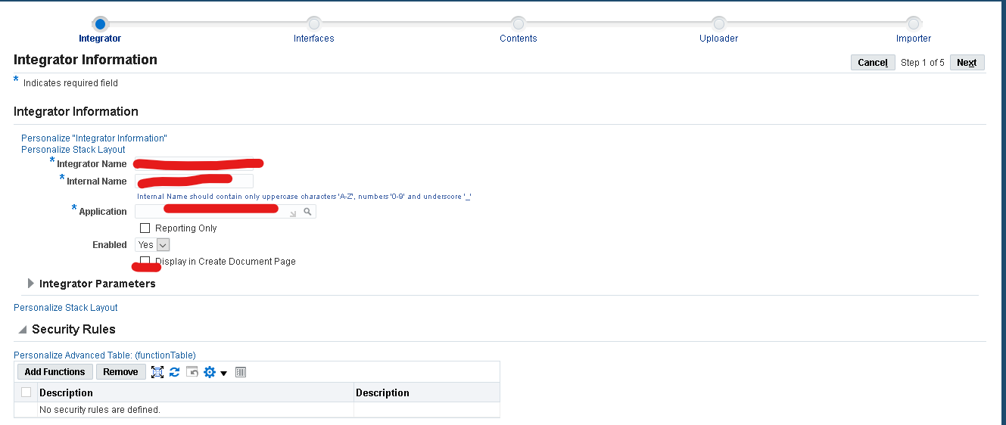
↓
In the next Train interface need to fill the interface data as well as the table name in it
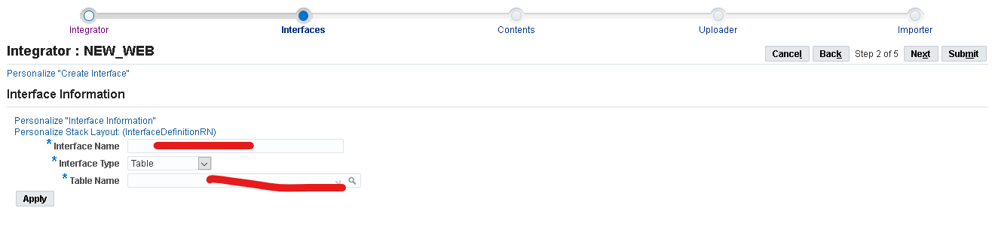
↓
In the contents , uploader and Importer trains no need to fill any data just need to be remain same and click on the submit button.

- Creating the layout
Go to data integration responsibility select the define layout option then the form will opens.
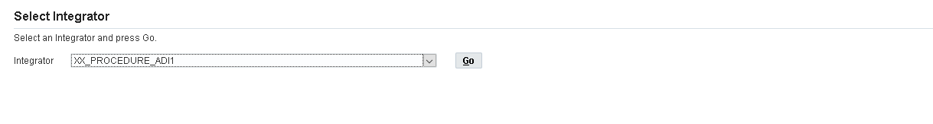
Select the integrator name which is already created in the Integrator form click on go.
↓

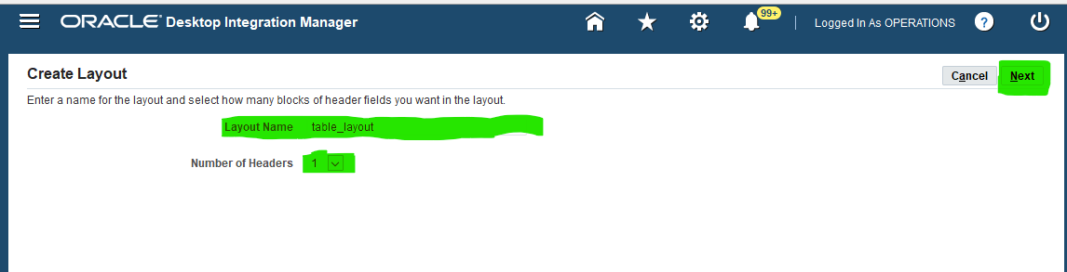
In the create layout give the layout name and select no of headers as 1 then click on next.
↓
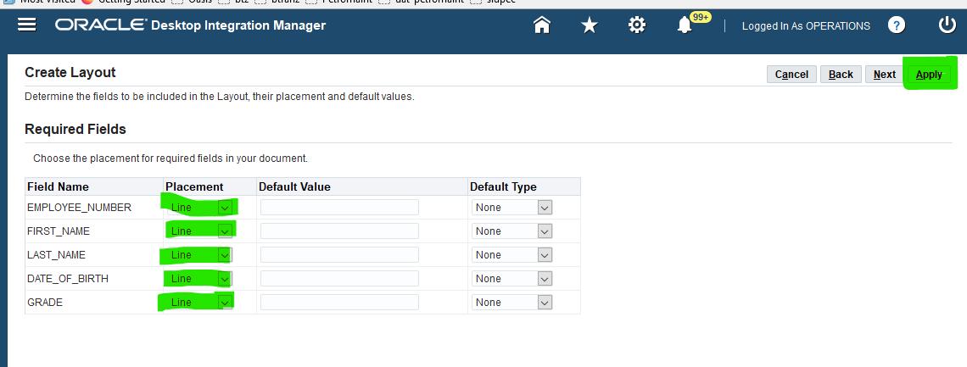
Check the required fields arrange them in the proper order for further usage.
Then it shows the popup as layout is created successfully .

5.Creating document :
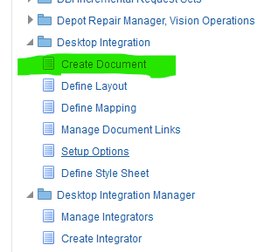
Select the create document in the desktop integrator responsibility
Select the integrator name in the given option.
↓
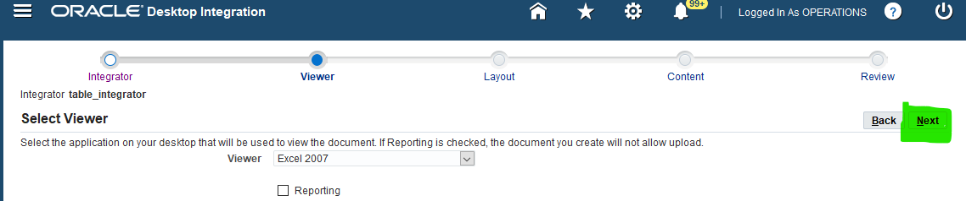
After that select the viewer based on the version of the excel.
↓
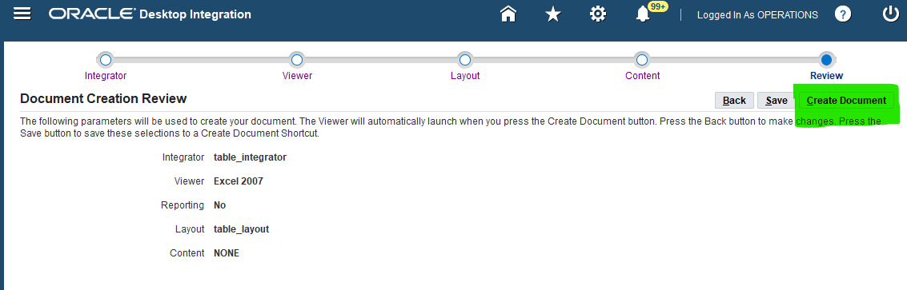
Select the option create document then the excel format will be opens to fill the required data.

2. Procedure based web adi
- Creating a package and procedure.
- Creating the web adi
- Creating the layout.
- Creating document.
Creating a package and procedure
First create a package include the procedure and function along with the parameters in procedure after that create the package body in it.

Package specification
create or replace PACKAGE XX_PROCEDURE_ADI1 AS

PROCEDURE XX_INSERT_DATA_ADI (
P_EMPLOYEE_NUMBER VARCHAR2
,P_FIRST_NAME VARCHAR2
,P_LAST_NAME VARCHAR2
,P_DATE_OF_BIRTH DATE
,P_GRADE VARCHAR2
);
END;
create or replace PACKAGE BODY XX_PROCEDURE_ADI1 AS

PROCEDURE XX_INSERT_DATA_ADI (
P_EMPLOYEE_NUMBER VARCHAR2
,P_FIRST_NAME VARCHAR2
,P_LAST_NAME VARCHAR2
,P_DATE_OF_BIRTH DATE
,P_GRADE VARCHAR2
) IS

lc_sqlerrm VARCHAR2 (2000);
lc_error_msg VARCHAR2 (2000);

l_responsibility_id NUMBER := apps.fnd_global.resp_id;
l_resp_application_id NUMBER := apps.fnd_global.resp_appl_id;
l_org_id NUMBER := apps.fnd_global.org_id;
l_user_id NUMBER := apps.fnd_global.user_id;

BEGIN

INSERT INTO XX_INTEGRATOR_ADI (
EMPLOYEE_NUMBER
,FIRST_NAME
,LAST_NAME
,DATE_OF_BIRTH
,GRADE
)
VALUES (
P_EMPLOYEE_NUMBER
,P_FIRST_NAME
,P_LAST_NAME
,P_DATE_OF_BIRTH
,P_GRADE
);

COMMIT;

EXCEPTION WHEN OTHERS THEN
lc_sqlerrm := SUBSTR(SQLERRM,1,1999);

raise_application_error (-20001, 'OTHER_EXCEPTION - MSG | ' || lc_sqlerrm);
END;

END;

Creating web adi:
Open the oracle ebs application
↓
Open the create integrator.
Fill the integrator name, Internal name & application name as well as the click on the check box.

↓
In the next Train interface need to fill the interface data as well as select the interface type as ‘API-PROCEDURE’ enter the package name as well as procedure in it.
Select the ‘fnd_msg_code‘ in the api returns check box.
Click on apply.
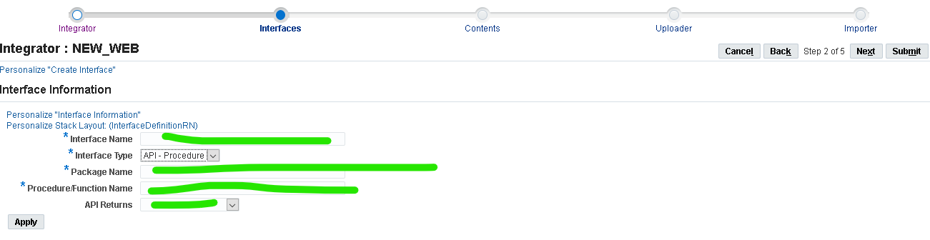
↓
In the remaining trains like contents ,uploader,Importer are use to remain same and click on submit button.
Creating the layout
Go to data integration responsibility select the define layout option then the form will opens.

Select the integrator name which is already created in the Integrator form click on go.
↓


In the create layout give the layout name and select no of headers as 1 then click on next.
↓

Check the required fields arrange them in the proper order for further usage.
Then it shows the popup as layout is created successfully .

Creating document :

Select the create document in the desktop integrator responsibility
Select the integrator name in the given option.
↓

After that select the viewer based on the version of the excel.
↓

Select the option create document then the excel format will be opens to fill the required data.

3. Adding the calendar lov to the column through web adi.
Open the desktop integrator manager responsibility select the manage component option in it.
Select the create component option .
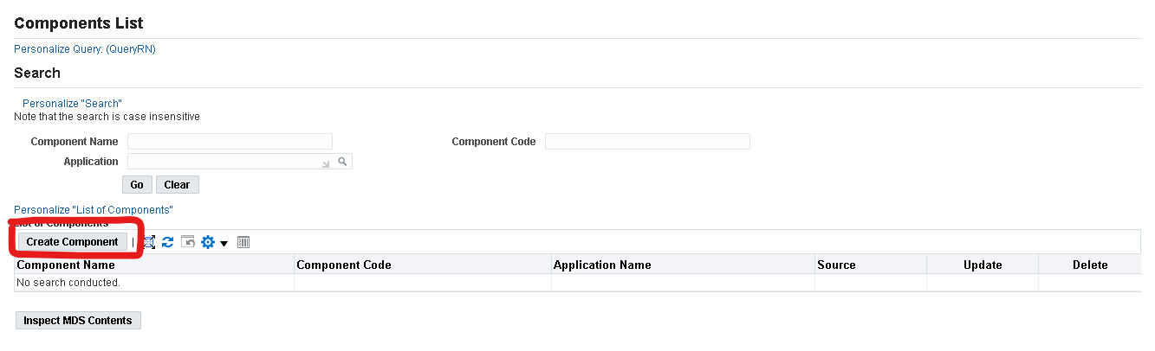
↓
Fill the required data as shown in it like display name ,Internal Name,
Application and component type as ‘Calender’ after that click on apply button to move further.
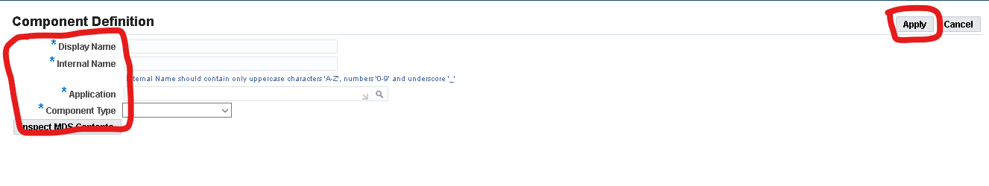
↓
Assign the table-column, table-select-column name as the date column name which is same as parameter in the procedure.
Click on apply button. Copy or remember the display name of the component.
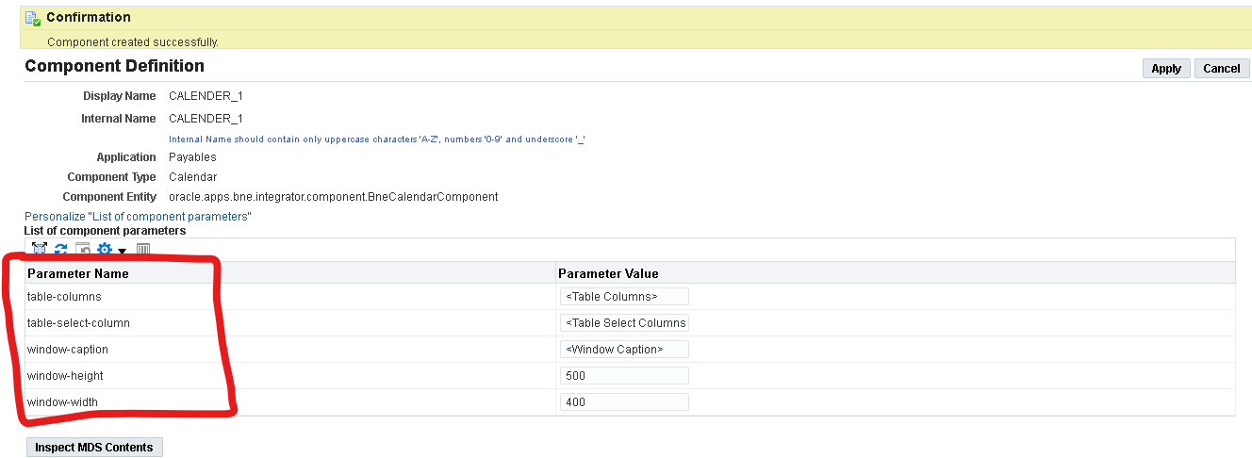
↓
Go to desktop integrator manager and select manage integrator
Enter the integrator name click on update then go to interface

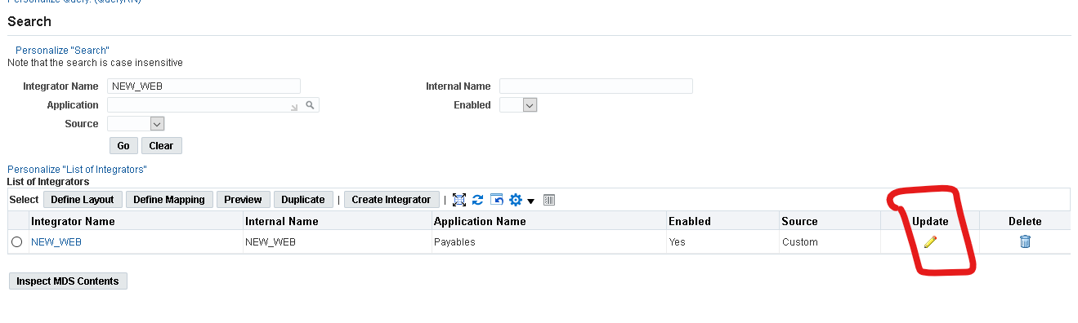
↓
In the interface train update the date column and add the validation type as ‘JAVA’ and add component name and lov type as the ‘Standard’ click on apply. Then click on the submit button.
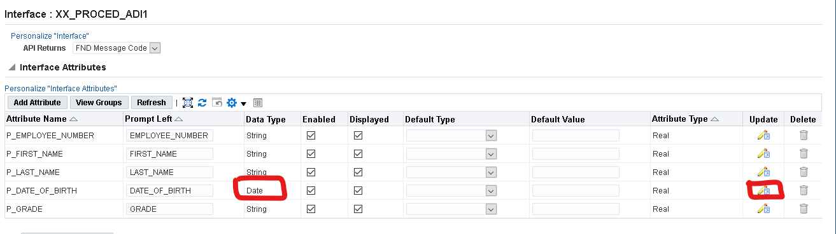
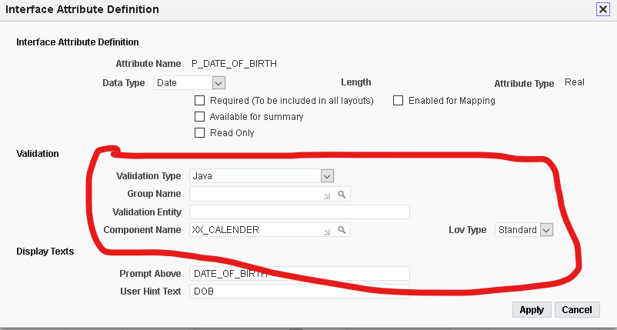
↓
Then same procedure like create layout and create document in it.
Excel sheet after double click on the column the calendar will be appear.

